Design Document

**Zoho Books Invoice Automation**

* **Outcome:**

The outcome of this design is the implementation of an automated system within Zoho Flow to ensure invoices are automatically sent to customers upon creation in Zoho Books, thereby enhancing billing efficiency and customer satisfaction.

* **Use Case Implementation Steps:**

**Implementation Stage 1: Accessing Zoho Flow**

**Description:** Log in to the Zoho Flow platform and navigate to the "Flows" section to access or create the automation workflow.**Steps:**

1. Log in to Zoho Flow with the necessary credentials.
2. Go to the **Flows** section.
3. Access the specific flow related to Zoho Books.

**Input:** Access to the Zoho Flow platform.

**Output:** The Zoho Flow builder interface for the invoice automation flow.

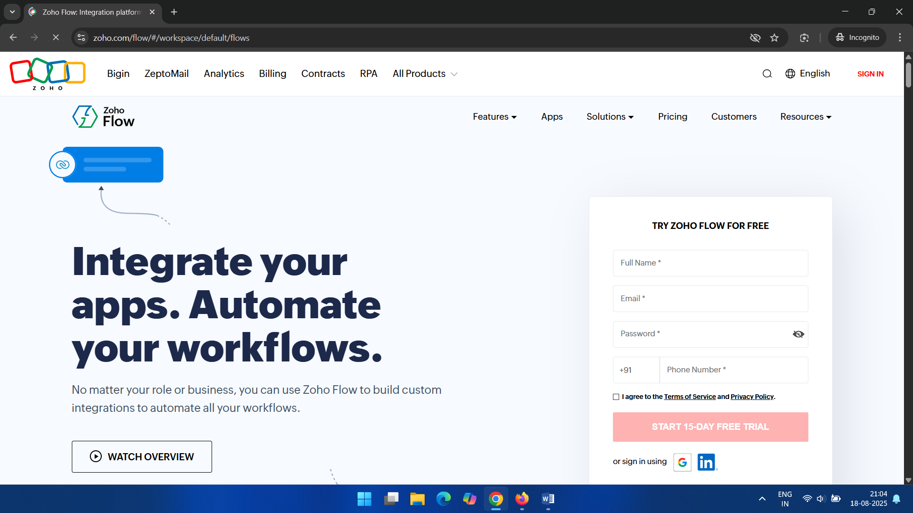

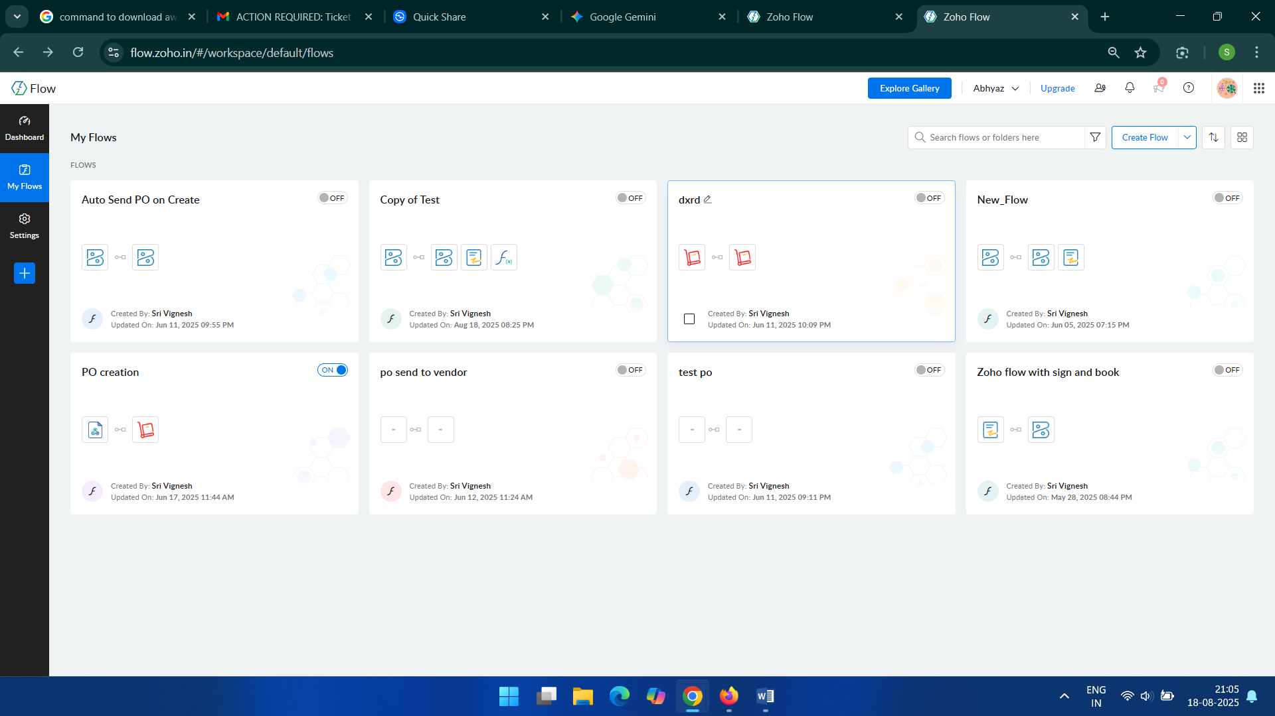

**Implementation Stage 2: Creating the Automation Rule**

**Description:** Design and configure the workflow to trigger when a new invoice is created in Zoho Books.

**Steps:**

1. Set the trigger to **Zoho Books**.
2. Select the trigger event as **Invoice created**.
3. Add the **Fetch Invoice** action to retrieve the invoice details.
4. Include the **Send document** action to email the invoice.
5. Add a **Delay** step to pause the workflow.
6. Add the **Check invoicePaymentStatus** action.
7. Use a **Decision** block to create conditional logic based on the payment status.
8. Add a final **Send document** action for a specific condition.

**Input:** A new invoice being created in Zoho Books.

**Output:** A multi-step Zoho Flow that is triggered and begins execution.

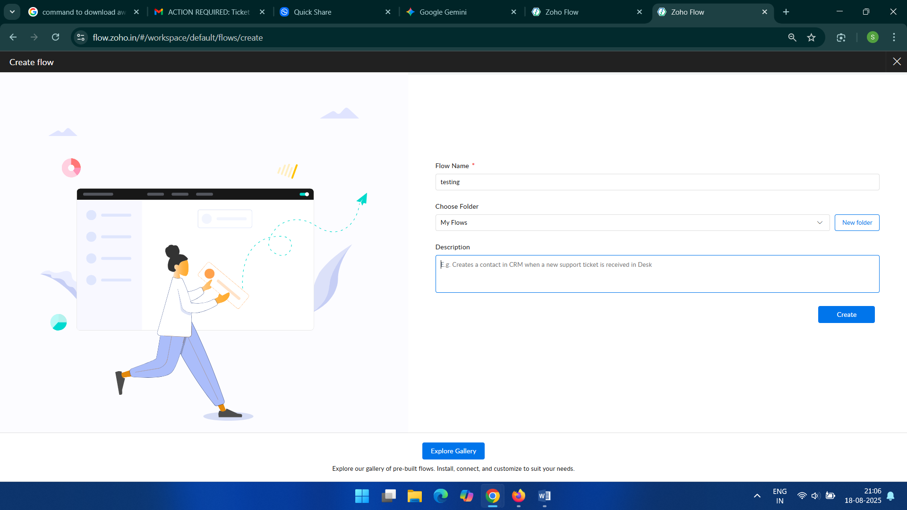

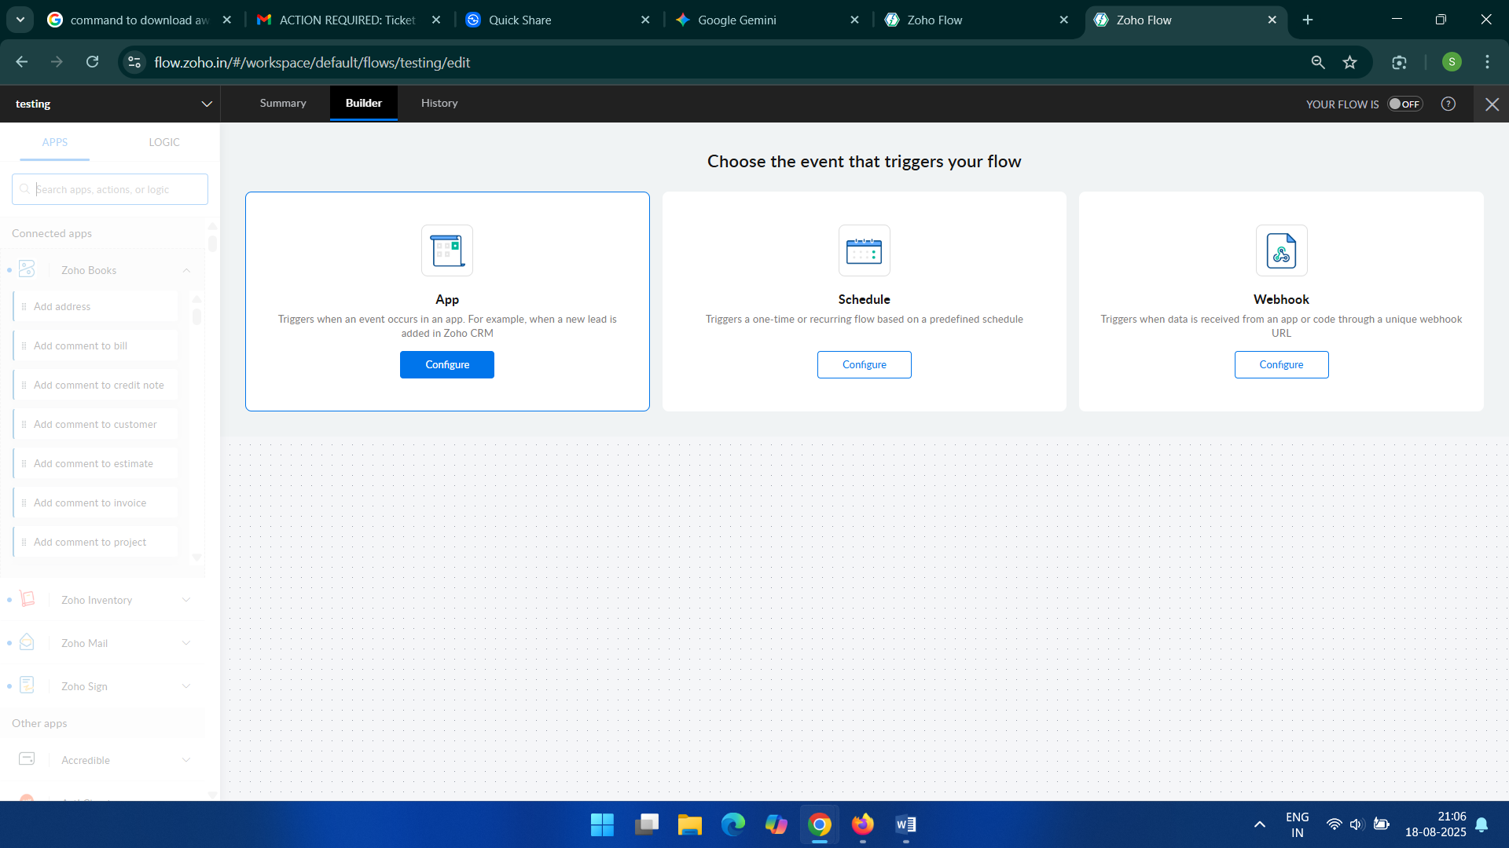

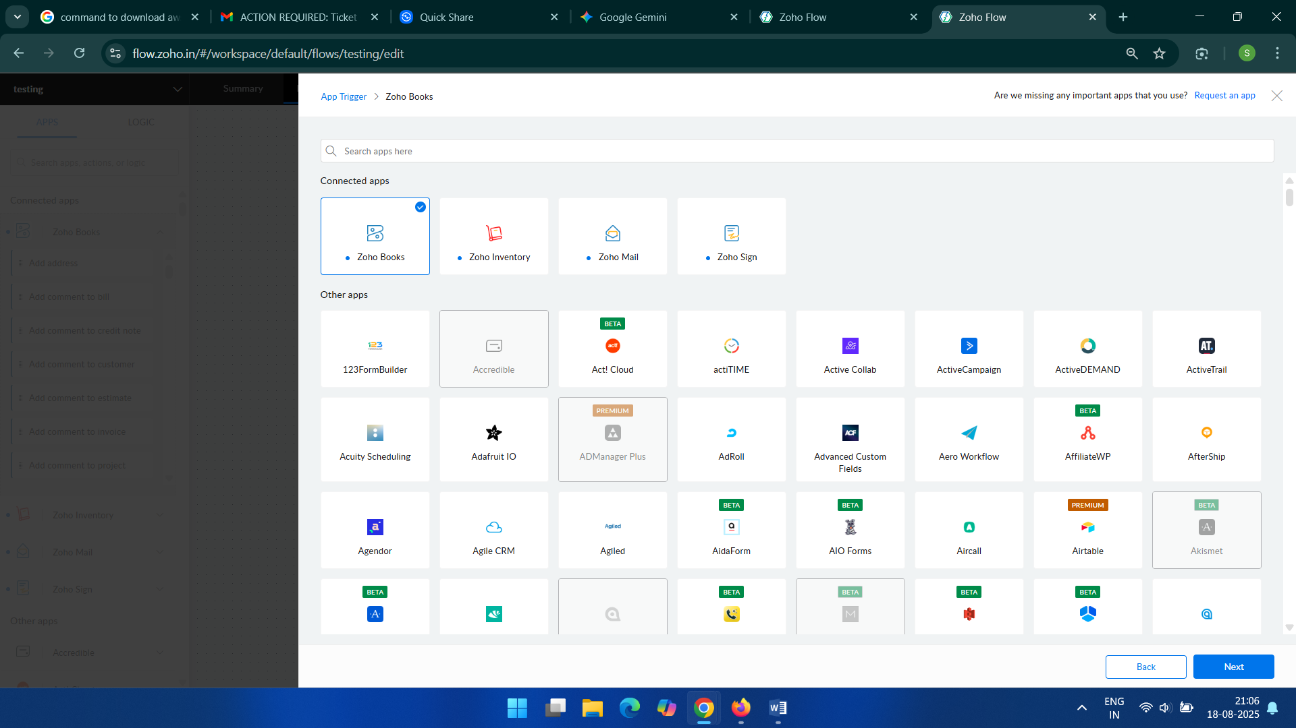

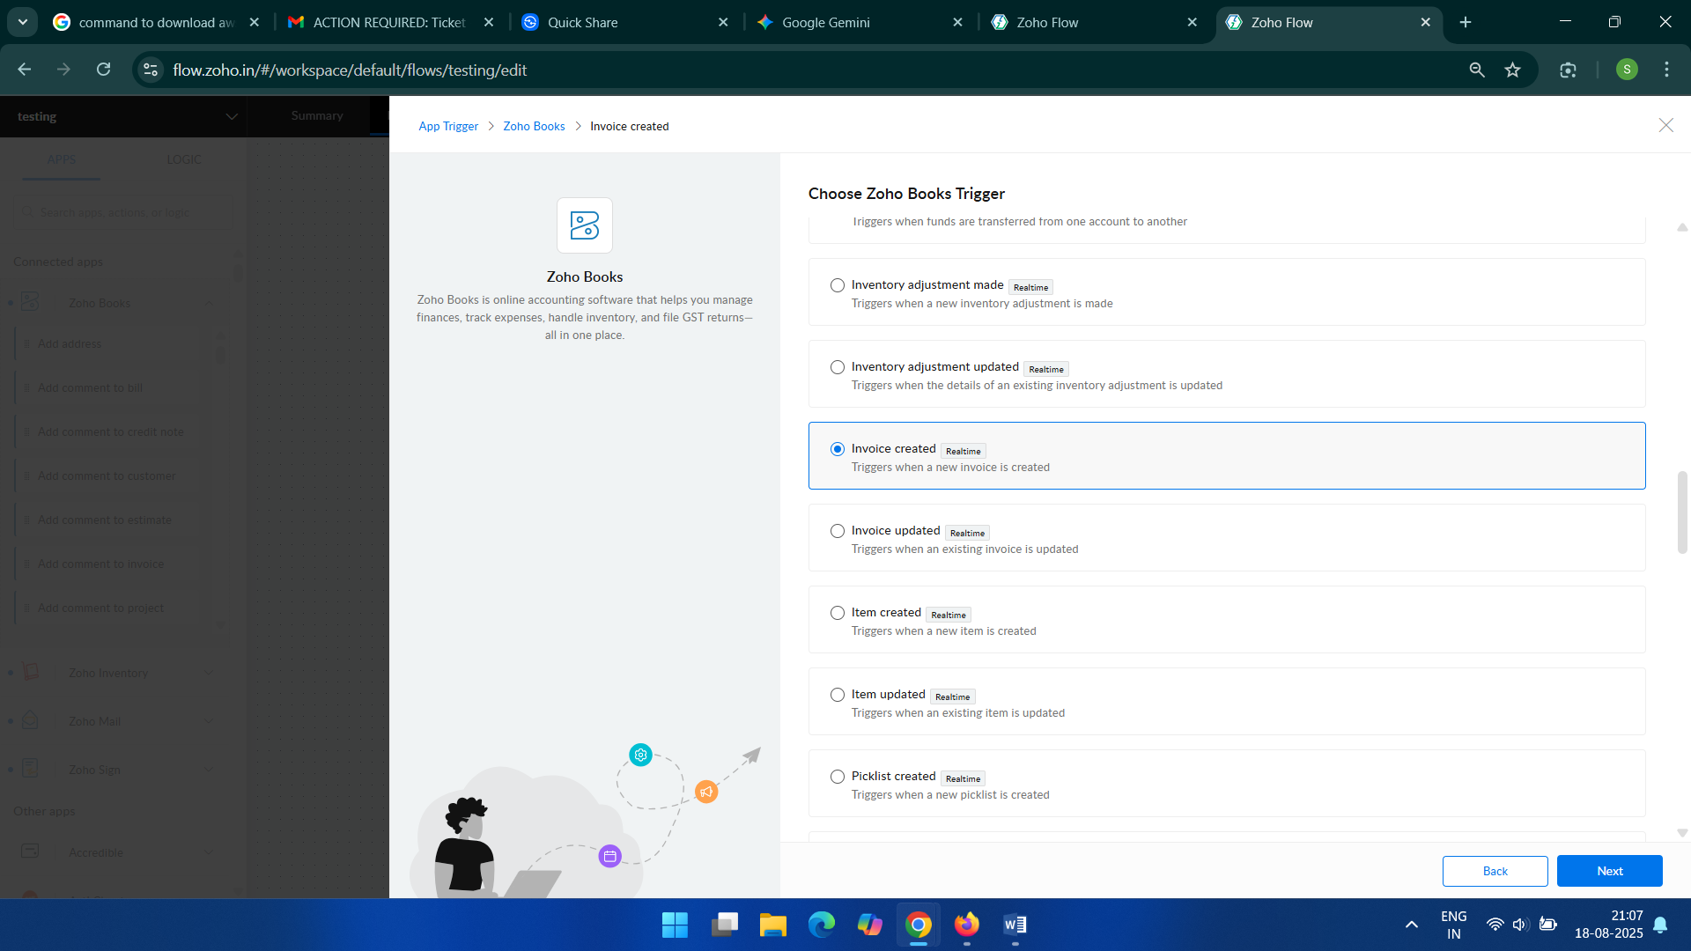

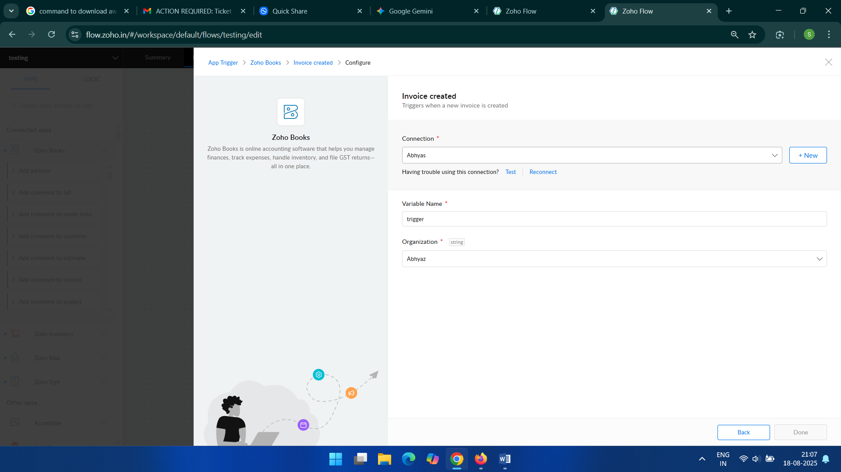

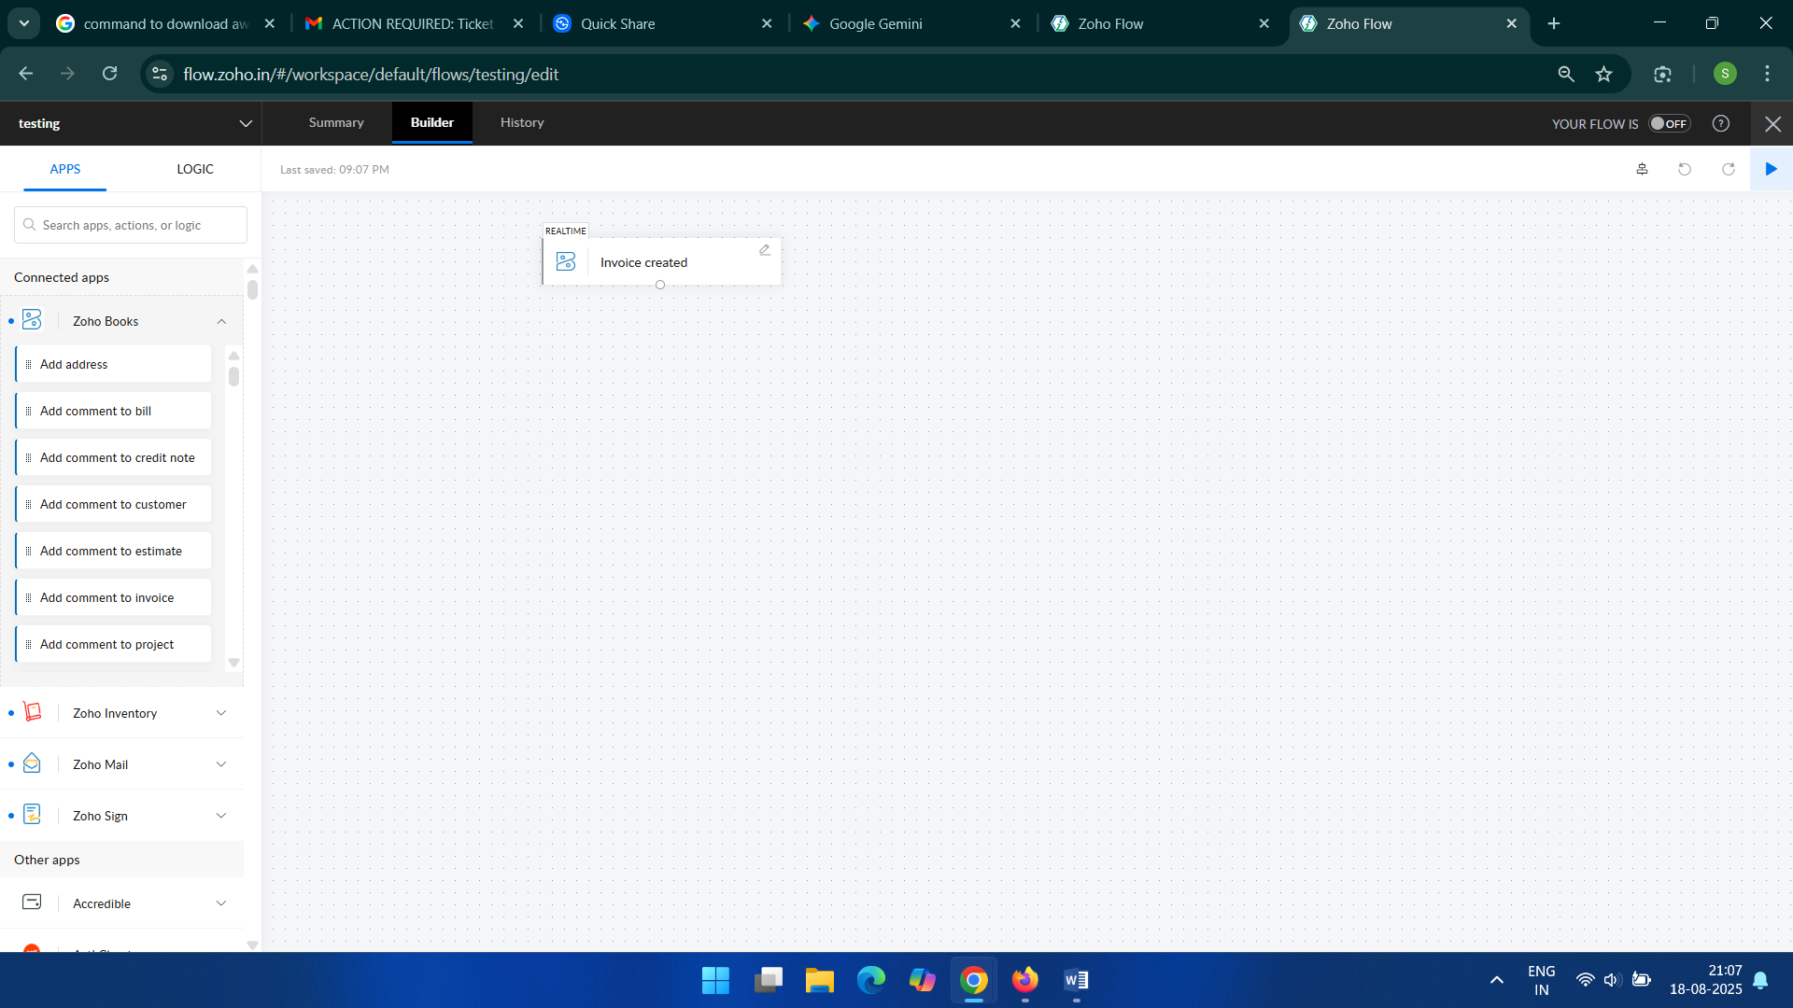

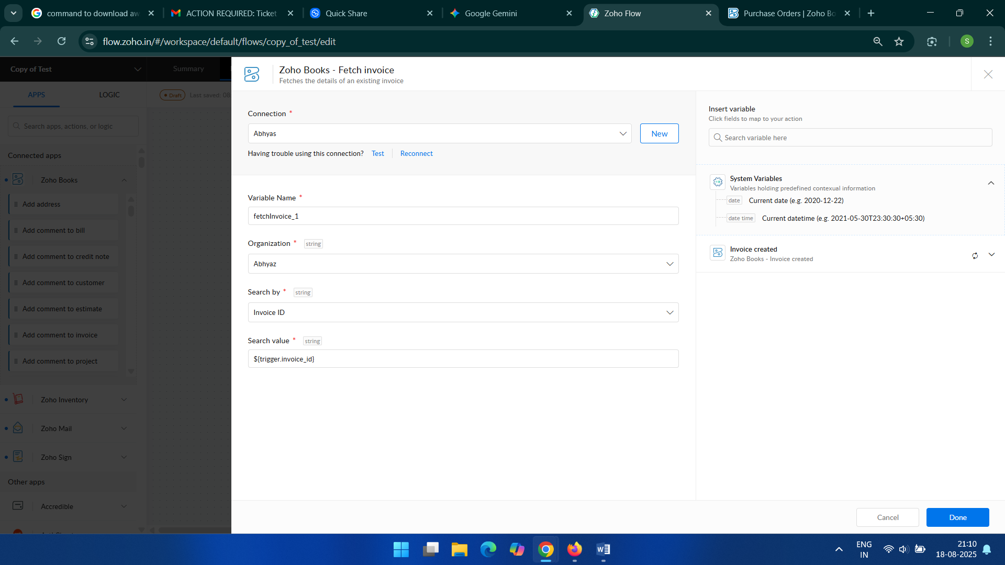

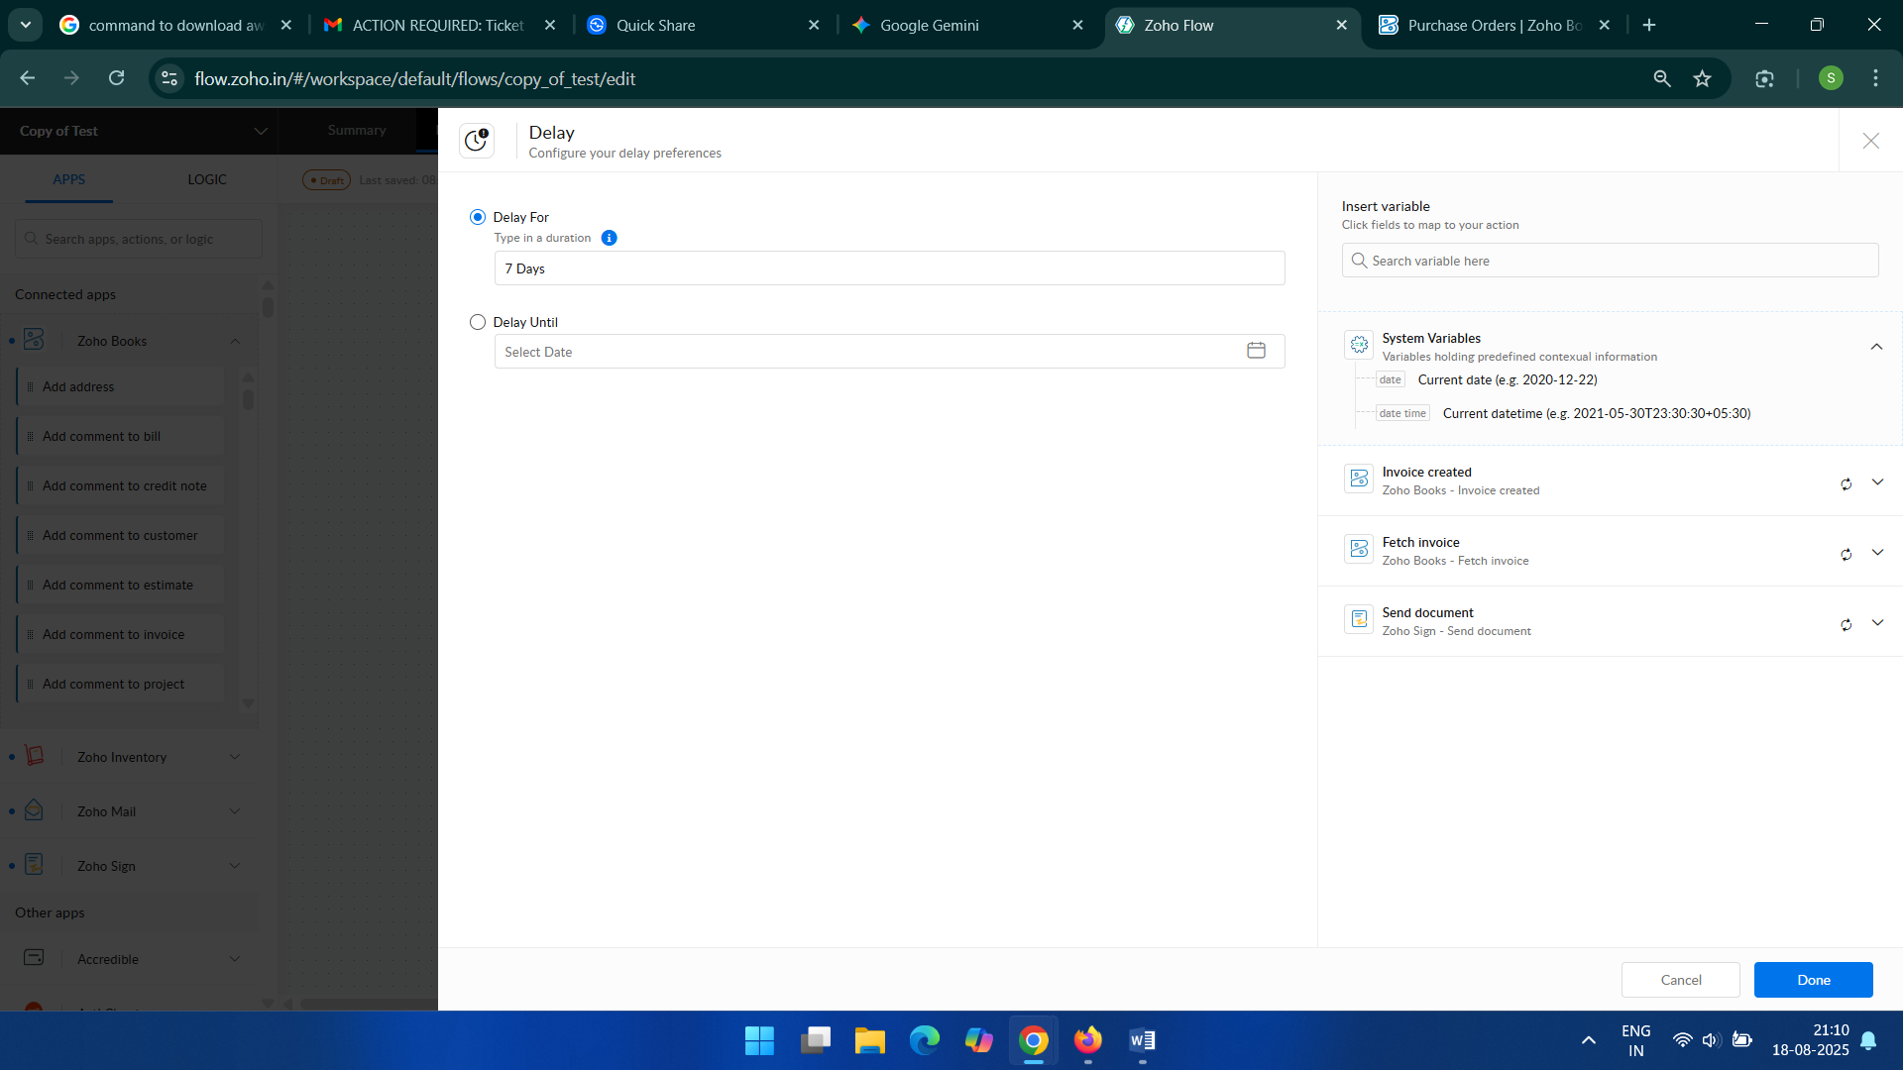

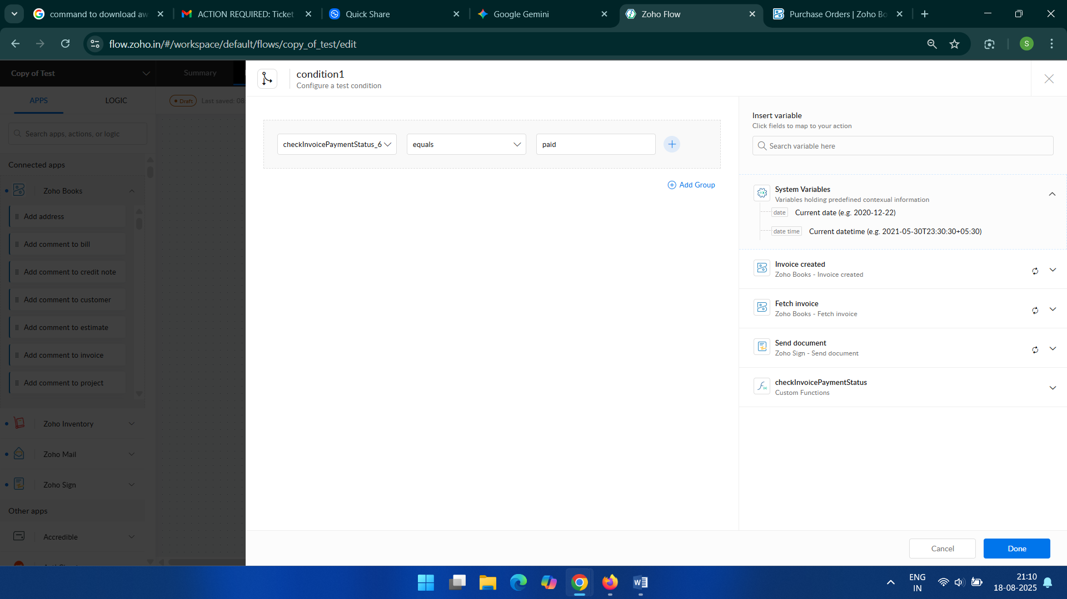

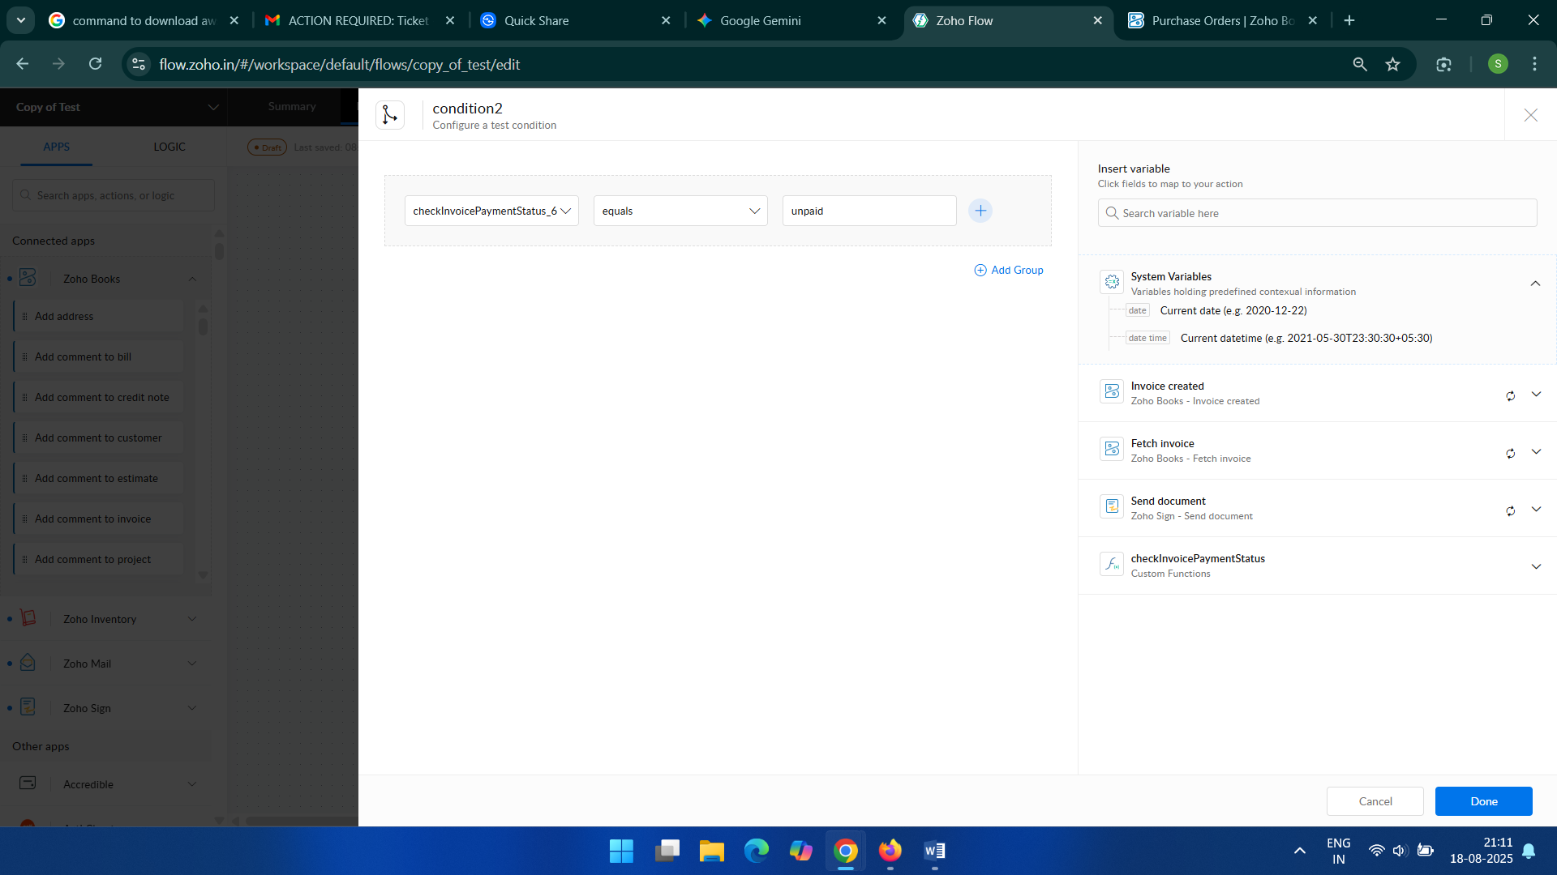

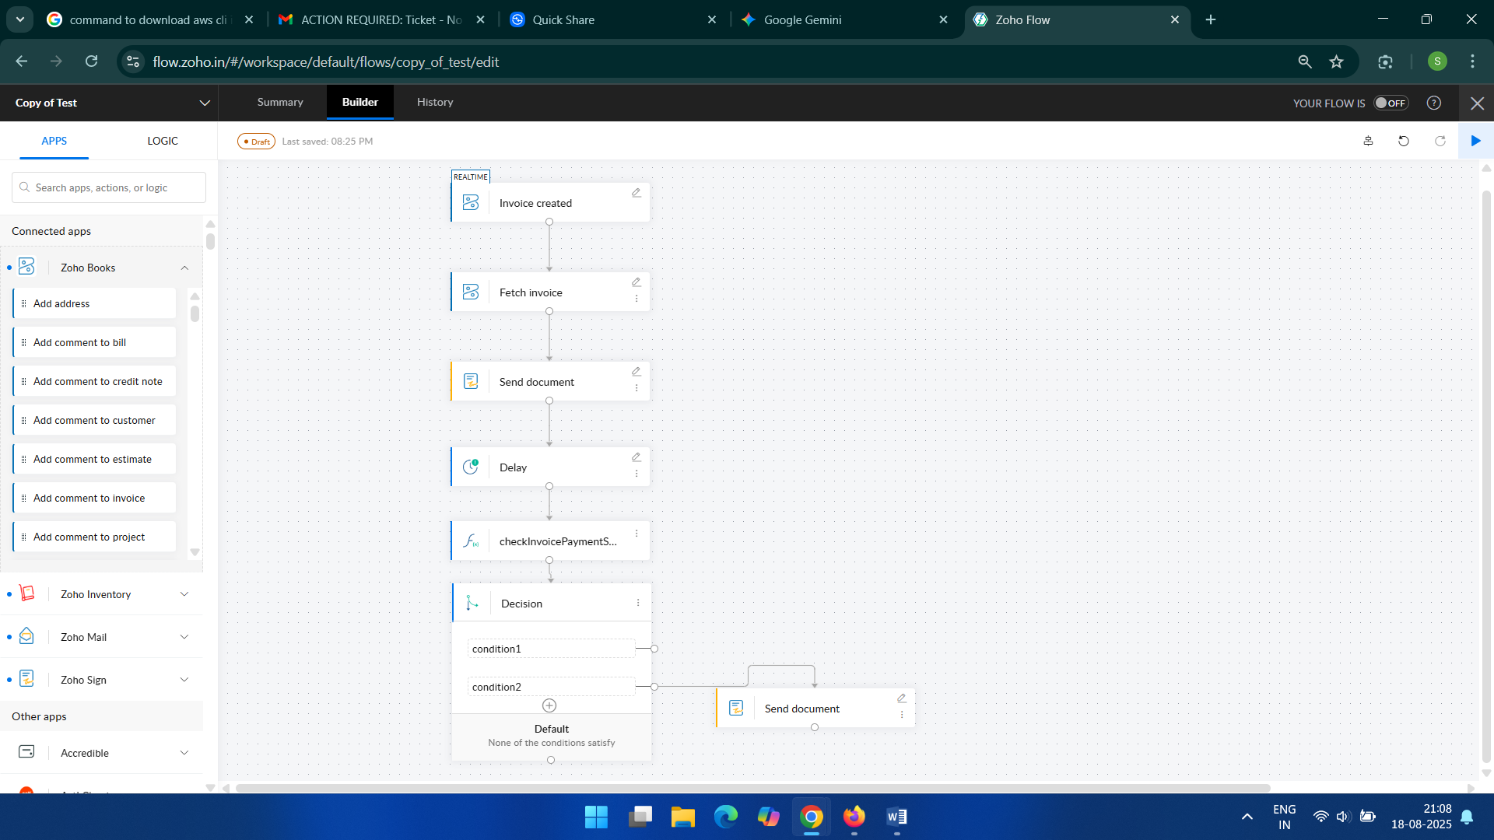

**Implementation Stage 3: Configuring the Zoho Books and Email Actions**

**Description:** Define the specifics of the data retrieval and email sending actions within the flow.

**Steps:**

1. For the "Fetch Invoice" action, map the Invoice ID from the trigger.
2. For the first "Send document" action, map the customer's email address and the invoice document from the fetched details.
3. Set the email subject and body content.
4. For the "Check invoicePaymentStatus" action, use the invoice ID to get the current status from Zoho Books.
5. In the "Decision" block, create conditions such as "If payment status is Paid" or "If payment status is Overdue."
6. For the final "Send document" action, configure it to send a different document based on the decision outcome.

**Input:** Invoice and customer data from Zoho Books.

**Output:** An automated email sent to the customer with the invoice attached.

**Implementation Stage 4: Testing and Deployment**

**Description:** Thoroughly test the configured flow to ensure it functions as intended, then deploy it for live use.

**Steps:**

1. Create a test invoice in Zoho Books.
2. Monitor the Zoho Flow history to confirm the flow triggers and executes without errors.
3. Check the customer's email to verify they received the invoice.
4. Manually update the payment status of the test invoice to check if the conditional logic works.
5. Verify that the second "Send document" action triggers under the correct conditions.
6. Once testing is successful, activate the Zoho Flow.

**Input:** Test scenarios and sample data.

**Output:** Verified and deployed automation flow.

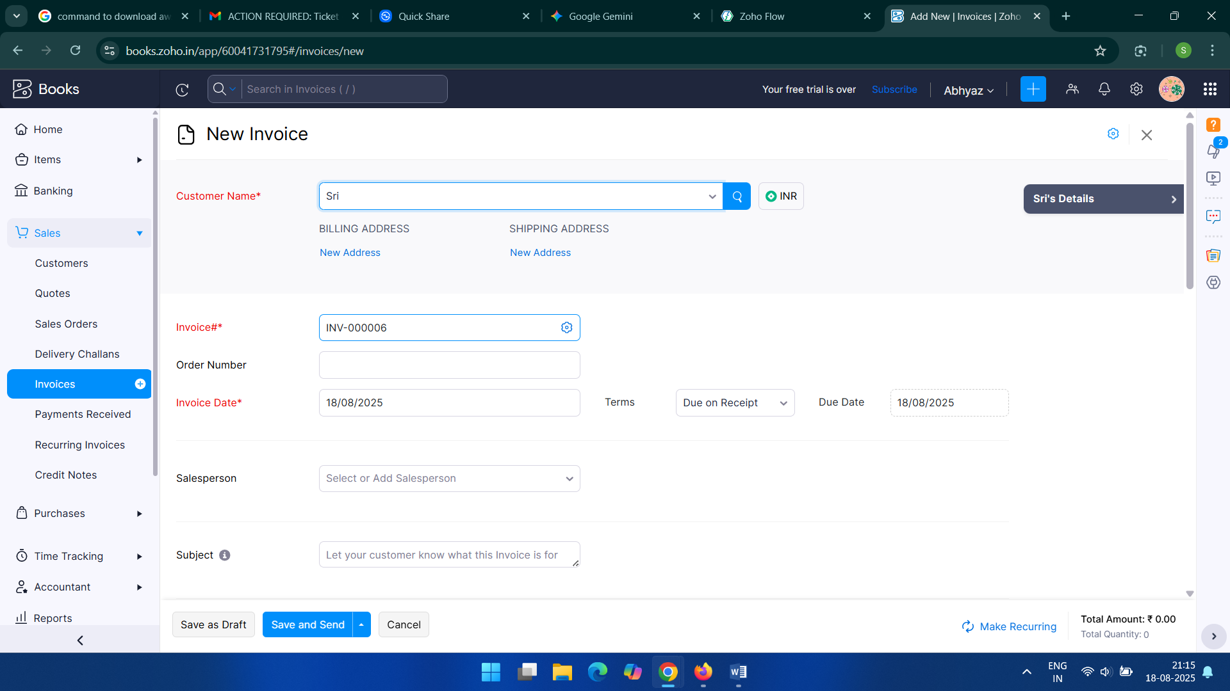

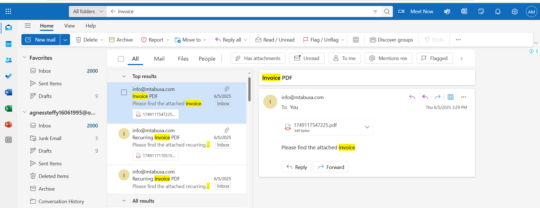

* **Target Audience:**
* **Automation Specialist / Trainee DevOps:** Responsible for the initial setup and maintenance of the flow.
* **Billing Team / Business Users:** Create invoices and benefit from the automation.
* **Clients:** Receive automated invoices via email.
* **Tool/Permission Required:**
* **Tool:** Zoho Flow, Zoho Books
* **Permission:** Admin privileges for both Zoho Flow and Zoho Books.